|  |
| --- |
|  |
| The Specification |
| [Type the document subtitle] |
|  |
| **[Your Name]** |
| **[Pick the date]** |

[Type the abstract of the document here. The abstract is typically a short summary of the contents of the document. Type the abstract of the document here. The abstract is typically a short summary of the contents of the document.]

Table of Contents

[To update the table of contents, right click the message below and select Update Field (F9 on PC, ⌥⌘U on Mac).]

**No table of contents entries found.**

1. Pages
   1. Page Tree

Home  
 Page 1  
 Page 2  
 Page 3

* 1. Home
     1. User Interface

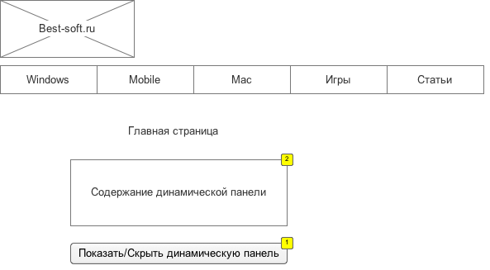

* + 1. Widget Table

| Footnote | Label | Interactions | Description |
| --- | --- | --- | --- |
| 1 |  | OnClick:  Case 1:  Toggle Visibility for Пример динамической панели |  |
| 2 | Пример динамической панели |  | Описание для динамической панели |

* + 1. Пример динамической панели
       1. State1
       2. User Interface

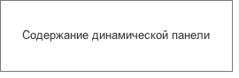

* 1. Page 1
     1. User Interface

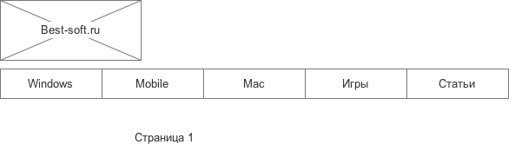

* 1. Page 2
     1. User Interface

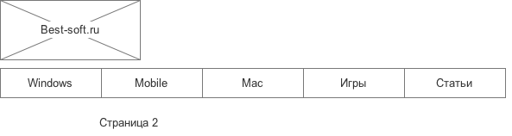

* 1. Page 3
     1. User Interface

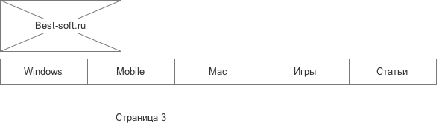

1. Masters
   1. Master List

Шапка

* 1. Шапка
     1. User Interface

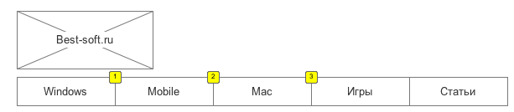

* + 1. Widget Table

| Footnote | Interactions |
| --- | --- |
| 1 | OnClick:  Case 1:  Open Page 1 in Current Window |
| 2 | OnClick:  Case 1:  Open Page 2 in Current Window |
| 3 | OnClick:  Case 1:  Open Page 3 in Current Window |